WPSEAL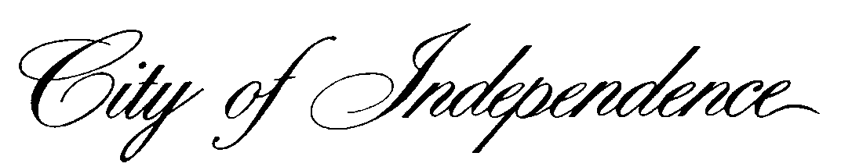

*HEALTH DEPARTMENT • COMMUNICABLE DISEASE & IMMUNIZATION UNIT*

*515 SOUTH LIBERTY STREET • P.O. BOX 1019 • INDEPENDENCE, MISSOURI 64051-0519*

[*www.independencemo.org*](http://www.independencemo.org) *• (816) 325-7185*

Dear Parents/Guardians:

The City of Independence Health Department is working with VaxCare and your child’s school to give the Meningitis vaccine to children in 11th and 12th grades. This vaccine will protect against meningococcal disease which is a serious bacterial illness that causes an infection of the covering of the brain and the spinal cord. Per the Missouri Department of Health and Senior Services, meningitis vaccine is required for entrance into 12th grade and first-year college students up through age 21 years who are living in residence halls.

We will hold vaccination clinics in February; specific dates for your child’s school can be found at the end of this letter or at [www.isdschools.org](http://www.isdschools.org). Attached you will find the most current Vaccine Information Statement on the meningococcal vaccine.

Also attached is a vaccine consent form for you to complete for your child to receive the meningococcal vaccine at his/her school. If you would like for your child to receive the meningococcal vaccine at school, please fill out the front and back of the accompanying form, sign it, and return it to your school nurse by the date listed in the chart below. Information collected will be provided to the Independence Health Department which in turn will be shared with Vaxcare for any billing needed. The health department will comply with all confidentiality requirements applicable under state and federal law, including, the Health Insurance Portability and Accountability Act (attached) and the Family Educational Rights and Privacy Act (FERPA) (20 U.S.C. § 1232g; 34 CFR Part 99). By signing and returning the attached consent form, you are specifically consenting to the release of the information you provide about your student to the Independence Health Department and, if applicable, to Vaxcare. The attached form will be forwarded directly to Independence Health Department and will not be maintained by Independence School District.

To complete the Payment Information section of the consent form, here’s what you need to do:

* If your child has Medicaid, please complete the form and provide their Medicaid number and plan name for billing purposes in the area on the form indicating Medicaid.
* If your child is not Medicaid eligible, please complete the form and indicate if your child has an eligible insurance listed on the form that will pay for the meningococcal vaccine and provide all the insurance information. Please review your plan to be sure you have coverage for vaccines.
* If your child is not eligible for Medicaid or private insurance, please indicate on the form in the “NO INSURANCE” box.

Please visit the CDC’s web site, Meningococcal Vaccines for Preteens and Teens, at http://www.cdc.gov/vaccines/who/teens/vaccines/mening.html. Your child’s health care provider also can answer your questions about meningococcal disease.

If you have any questions about the vaccine or the vaccination clinics, please call the Independence Health Department at 816-325-7185 from 8:00 a.m. to 5:00 p.m.

Sincerely,

City of Independence Health Department

Communicable Disease and Immunization

|  |  |  |
| --- | --- | --- |
| School | Consent form due back to school | Clinic date* |
| Truman, Chrisman | Thursday  February 4, 2016 | Thursday  February 18, 2016 |
| Van Horn, Independence Academy | Thursday  February 4, 2016 | Friday  February 19, 2016 |

*Dates are subject to change based on vaccine availability.