WPSEAL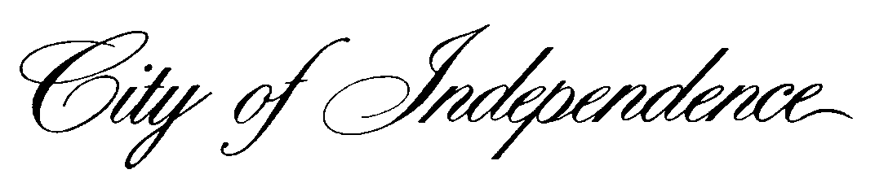

*HEALTH DEPARTMENT • COMMUNICABLE DISEASE & IMMUNIZATION UNIT*

*515 SOUTH LIBERTY STREET • P.O. BOX 1019 • INDEPENDENCE, MISSOURI 64051-0519*

[*www.independencemo.org*](http://www.independencemo.org) *• (816) 325-7185*

Dear Parents/Guardians:

The City of Independence Health Department is working with VaxCare and your child’s school to give the Tdap (Tetanus-diphtheria-acellular Pertussis) vaccine to children at school. We will hold these vaccination clinics on February 26, 2016 at Bridger Middle School.

Vaccine protection for pertussis, tetanus, and diphtheria can fade with time. Preteens (age 11 or 12 years) should get a dose of Tdap, the booster for tetanus, diphtheria, and pertussis. Teens that did not get this vaccine at their 11- or 12-year-old check-up should get vaccinated at the next opportunity available. In Missouri, Tdap is required for 8th grade. Being up-to-date with Tdap is especially important for preteens and teens that will be around infants.

Attached is a vaccine consent form for you to complete for your child to receive the Tdap vaccine at his/her school. If you would like for your child to receive the Tdap vaccine at school, please fill out and sign the accompanying form and return it to your school nurse by February 11, 2016. Information collected will be provided to the Independence Health Department which in turn will be shared with Vaxcare for any billing needed. The health department will comply with all confidentiality requirements applicable under state and federal law, including, the Health Insurance Portability and Accountability Act and the Family Educational Rights and Privacy Act (FERPA) (20 U.S.C. § 1232g; 34 CFR Part 99). By signing and returning the attached consent form, you are specifically consenting to the release of the information you provide about your student to the Independence Health Department and, if applicable, to Vaxcare. The attached form will be forwarded directly to Independence Health Department and will not be maintained by Independence School District.

To complete the Payment Information section of the form, here’s what you need to do:

* If your child has Medicaid, please complete the form and provide their Medicaid number and plan name for billing purposes in the area on the form indicating Medicaid.
* If your child is not Medicaid eligible, please complete the form and indicate if your child has an eligible insurance listed on the form that will pay for the Tdap vaccine and provide all the insurance information. There will be no out of pocket cost collected at the time of service, but please check with your insurance company for details on vaccine coverage.
* If your child is not eligible for Medicaid or private insurance, please indicate on the form in the “NO INSURANCE” box.

Please review the attached Vaccine Information Statement and visit <http://www.health.mo.gov/living/wellness/immunizations/pdf/48.pdf> for more information on required and recommended vaccines for adolescents. Your child’s health care provider also can answer your questions about the Tdap vaccine and other vaccines.

Please return your consent form to your school by February 11, 2016. If you have any questions about the vaccine or the vaccination clinics, please call the Independence Health Department at 816-325-7185 from 8:00 a.m. to 5:00 p.m.

Sincerely,

City of Independence Health Department

Communicable Disease and Immunization